Data quality is a measure of the condition of data based on factors such as accuracy, completeness, consistency, reliability and whether it's up to date.

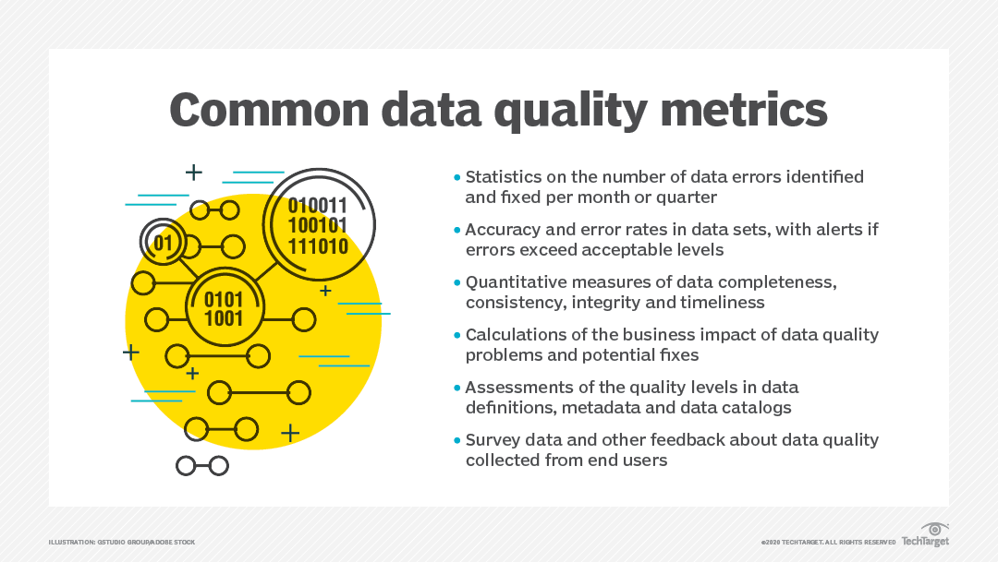

in organization too assure data we make process by quality metrics like below :

compare between two of table data entry specialist and master data and make difference between of them reflect to percentage to make indicator to whats important to change

too assure blank data